Exercise-1 Singleton Pattern Example
using System;
namespace SingletonPatternExample
{
public sealed class Logger
{
private static Logger instance = null;
private Logger()
{
Console.WriteLine("Logger Instance Created");
}
public static Logger GetInstance()
{
if (instance == null)
{
instance = new Logger();
}
return instance;
}
public void Log(string message)
{
Console.WriteLine("LOG: " + message);
}
}
class Program
{
static void Main(string[] args)
{
Logger logger1 = Logger.GetInstance();
Logger logger2 = Logger.GetInstance();
logger1.Log("Application Started");
logger2.Log("Processing Data");
if (logger1 == logger2)
{
Console.WriteLine("Both logger1 and logger2 refer to the same instance.");
}
else
{
Console.WriteLine("Different instances created.");
}
}
}
}
OUTPUT:
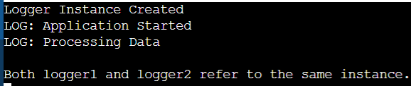

Exercise-2 FactoryMethodPattern
Code:
using System;

interface IDocument
{
void Open();
}

class WordDocument : IDocument
{
public void Open()
{
Console.WriteLine("Word Document Opened");
}
}

class PdfDocument : IDocument
{
public void Open()
{
Console.WriteLine("PDF Document Opened");
}
}

class ExcelDocument : IDocument
{
public void Open()
{
Console.WriteLine("Excel Document Opened");
}
}

abstract class DocumentFactory
{
public abstract IDocument CreateDocument();
}

class WordFactory : DocumentFactory
{
public override IDocument CreateDocument()
{
return new WordDocument();
}
}

class PdfFactory : DocumentFactory
{
public override IDocument CreateDocument()
{
return new PdfDocument();
}
}

class ExcelFactory : DocumentFactory
{
public override IDocument CreateDocument()
{
return new ExcelDocument();
}
}

class Program
{
static void Main(string[] args)
{
DocumentFactory wordFactory = new WordFactory();
IDocument word = wordFactory.CreateDocument();
word.Open();

DocumentFactory pdfFactory = new PdfFactory();
IDocument pdf = pdfFactory.CreateDocument();
pdf.Open();

DocumentFactory excelFactory = new ExcelFactory();
IDocument excel = excelFactory.CreateDocument();
excel.Open();
}
}
OUTPUT:
